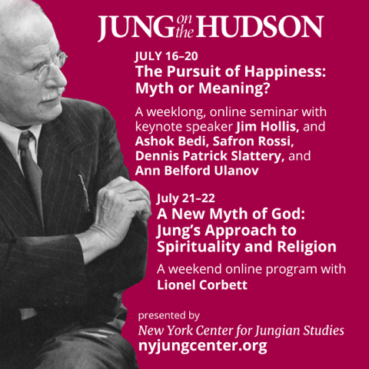
https://nyjungcenter.org/trip/joh23/#

