In the Eye of the Storm

Staying Centered in a Personal and Collective Crisis
  - Presented by Ashok Bedi, M.D. & Robert BJ Jakala PH.D.
Saturday May 6, 2023, A LIVE PRESENTATION - 9 AM- 3 PM
324 West Vine Street, Milwaukee, WI 53212 (Street Parking) -Ring the doorbell to enter – Not Disabled Accessible.
5 Hours of CE credits – One hour lunch on your own
Fees: $ 120.00
Student Fees: $ 60.00
TO REGISTER: https://jungchicago.org/blog/product/in-the-eye-of-the-storm-staying-centered-in-a-personal-and-collective-crisis/

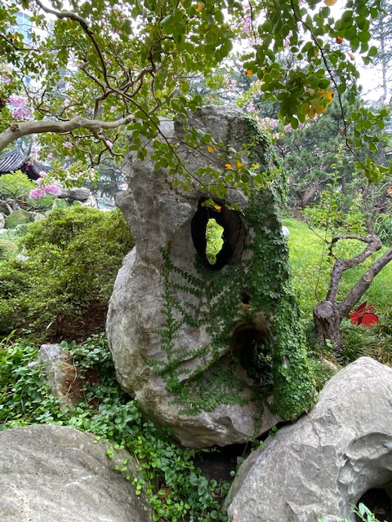
During a personal or collective crisis, our ego consciousness is overwhelmed and retreats into the healing depths of the personal and collective unconscious with a petition for guidance to negotiate the crisis and trauma. In the unconscious, the Self archetype is activated to respond to this petition. Self consults the archetypes to construct a new paradigm to guide our consciousness. This new paradigm now emerges into our consciousness as a new image as a Mandala. This new image is experienced as meaningful, affectively charged and numinous and becomes a GPS to guide us on; not only to deal with the crisis or trauma but to reset our path towards our teleos and new beginning. The presenters will explore the healing power of the image and amplify a series of images that Synchronistically emerged in collaboration between the presenters in response to the COVID pandemic, racial justice movement and global upheaval. Participants are encouraged to bring an image that has been meaningful to them during this crisis. Participants will be invited to construct their own mandala using some of these insights.

Learning Objectives
- Describe the psychodynamic adaptation to crisis and trauma mediated by the Self and its Archetypes.
- Explore the activation of a Complementary Image to fill in the missing pieces of Consciousness to optimally respond to the Situation.
- Discover the healing potential of the Image using authors’ and participants’ images.
- Demonstrate a method of creating a Healing Mandala Image by participants.
- Assess the neuroscience of the image.
Presenters

Ashok Bedi MD – Jungian Analyst
  - 1220 Dewey Avenue, Wauwatosa, WI 53213
  - PH: (414) 219 9039
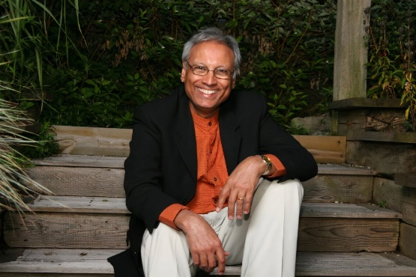
  - Email: ashokbedi@tulawellnessllc.com
Ashok Bedi, M.D. is a Jungian psychoanalyst and a board-certified psychiatrist. He is a member of the Royal College of psychiatrists of Great Britain, a diplomat in Psychological Medicine at the Royal College of Physicians and Surgeons of England, a Distinguished Life Fellow of the American Psychiatric Association. He is a Clinical Professor in Psychiatry at the Medical College of Wisconsin in Milwaukee and a training analyst at the Carl G. Jung Institute of Chicago. His books include In the Eye of the Storm- Staying Centered in Personal and Collective Crisis, The Spiritual Paradox of Addiction, Crossing the Healing Zone, Awaken the Slumbering Goddess: The Latent Code of the Hindu Goddess Archetypes, Retire Your Family Karma: Decode Your Family Pattern and Find Your Soul Path and Path to the Soul. He is the liaison for the IAAP for developing Jungian training programs in India and travels annually to India to teach, train the consult with the Jungian Developing groups at several centers in India including Ahmedabad and Mumbai. He leads the annual “A Jungian Encounter with the Soul of India” study group to several centers in India under the auspices of the New York Jung Foundation and the Carl Jung Institute of Chicago. His publications and upcoming programs may be previewed at www.pathtothesoul.com

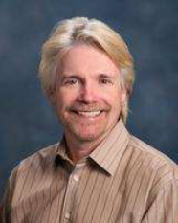
Robert “BJ” Jakala received his PhD (2006) in Depth Psychology from Pacifica Graduate Institute in Carpinteria, California. He retired his Jungian based private practice as a Licensed Marriage Family Therapist after thirty years in Woodland Hills, California. He was the Assistant Director of the Men’s Center of Los Angeles for five years.
He retired as a Registered Nurse at the Lynda and Stewart Resnick Neuropsychiatric Hospital at UCLA after thirty-three years. He has taught Stress Management and Resilience to the first year Nurse Residents at the Ronald Reagan UCLA Medical Center for the past sixteen years. He has been a core facilitator of the Circle of Caring, a three-day conference for health care workers, held at the Lake Arrowhead Conference Center since 2004. His love of photography, travel, and depth psychology are embedded in his semi-retirement life. He continues to teach depth psychological concepts in a variety of settings. He is co-author of In the Eye of the Storm- Staying Centered in Personal and Collective Crisis.

Suggested Readings
(Bedi, 2020; Jung, 1959, 1966, 1968a, 1968b, 1969a, 1969b, 1970a, 1970b, 1976; Jung, Hull, & Jung, 1966; Jung & Jaffé, 1963, 1983; Jung & Shamdasani, 2009; Rosen, Henderson, & Mascaro, 2007)

Bedi, A., MD; Jakala, BJ, PH.D. (2020). In the Eye of the Storm- Staying Centered in Personal and Collective Crisis. USA: Manforla Books.
Jung, C. G. (1959). Aion, researches into the phenomenology of the self, Volume 9 - Part 2 (Vol. 9, pt. 2). New York: Pantheon Books.
Jung, C. G. (1966). The spirit in man, art, and literature, Volume 15 (Vol. 20). New York: Pantheon Books.
Jung, C. G. (1968a). Alchemical studies, Volume 13 (Vol. 20). London: Routledge & Kegan Paul.
Jung, C. G. (1968b). Psychology and alchemy, Volume 12 (2 ed. Vol. 12). London: Routledge & Kegan Paul ; Princeton, N.J. : Princeton University Press.
Jung, C. G. (1969a). The archetypes and the collective unconscious, Volume 9 - Part 1 (2d ed. Vol. 1). Princeton: Princeton Univ. Press.
Jung, C. G. (1969b). The structure and dynamics of the psyche, Volume 8 (2d -- ed. Vol. 20). Princeton, N.J.: Princeton University Press.
Jung, C. G. (1970a). Civilization in transition, Volume 10 (2 ed. Vol. 20). Princeton, N.J.: Princeton University Press.
Jung, C. G. (1970b). Mysterium coniunctionis: an inquiry into the separation and synthesis of psychic opposites in alchemy, Volume 14 (2d -- ed. Vol. 20). Princeton, N.J.: Princeton University Press.
Jung, C. G. (1976). The symbolic life: miscellaneous writings, Volume 18 (Vol. 18). Princeton, N.J.: Princeton University Press.
Jung, C. G., Hull, R. F. C., & Jung, C. G. (1966). Two essays on analytical psychology, Volume 7 (2 ed. Vol. 7). London: Routledge & Kegan Paul.
Jung, C. G., & Jaffé, A. (1963). Memories, dreams, reflections. London: Collins and Routledge & Kegan Paul.
Jung, C. G., & Jaffé, A. (1983). C.G. Jung, word and image (Vol. XCVII, 2). Princeton, N.J.: Princeton University Press.
Jung, C. G., & Shamdasani, S. (2009). The red book = Liber novus (1st ed.). New York: W.W. Norton & Co.
Rosen, D., Henderson, P., & Mascaro, N. (2007). Empirical Study on the Healing Nature of Mandalas. Psychology of Aesthetics, Creativity, 1(3), 148-154. doi:0.1037/1931-3896.1.3.148

