Enigma: Transcendence from the Skin to the Soul
Product Code: AG-Bedi-Enigma-2019
Availability: Available
$165.00
CEs (PhD, PsyD, LPC, LCPC, LMFT, LCSW)
I want to add CEs (+$15.00)
CEs: Enter your license number
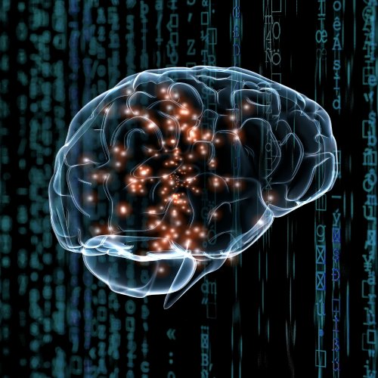

Enigma: Transcendence from the Skin to the Soul

Decoding the mysterious language of the Soul

Ashok Bedi, MD

For Registration: https://jungchicago.org/store/index.php?route=product/product&product_id=422

Friday, November 1, 2019 │ 8:30am-4:30pm
There is a constant dance between our Ego and our Soul. Both must maintain their autonomy and purposefulness. Our Ego and Persona is directed to adaptation to the outer world while the Soul must keep us aligned with our inner life and our teleological destiny. Ego and Persona must help us navigate the Spirit of the Time while the Soul must keep us aligned with the Spirit of the Depth. Each is one the two legs that we stand on in the present time and eternal time. Their task is to maintain alignment with their respective purpose yet coordinate to optimize one’s terrestrial Self with their Celestial Self. To undertake the Magnum Opus of Individuation, we need their partnership without being intrusive into each other’s domain. How these entities maintain this Complexio Oppositorium is an Enigma. Over eons, these Dioscuri twins have evolved a Mysterious language of the Soul. The decoding of this Enigma is mediated by the archetype of the Divine Tricksters: Hermes and Krishna. This Enigma to decode the Mysterious language of the Soul will be explored from a Neuroscience and Analytical perspectives.
Suggested Reading
Bedi, Ashok. 2013. Crossing the healing zone : from illness to wellness. Lake Worth, FL, Newburyport, MA: Ibis Press, a division of Nicolas-Hays, Inc., Lake Worth. Distributed to the trade by Red Wheel/Weiser.
Jung, C. G. 1970. Mysterium coniunctionis: an inquiry into the separation and synthesis of psychic opposites in alchemy, Volume 14. 2d -- ed. Vol. 20, Bollingen series. Princeton, N.J.: Princeton University Press.
Jung, C. G., and Aniela Jaffé. 1963. Memories, dreams, reflections. London: Collins and Routledge & Kegan Paul.
Jung, C. G., and Sonu Shamdasani. 2009. The red book = Liber novus. 1st ed, Philemon series. New York: W.W. Norton & Co.
MacLean, Paul D. 1990. The Triune Brain in Evolution: Role in Paleocerebral Functions: Springer Publications.
Pollan, Michael. 2018. How to change your mind - What the New Science of Psychedelics Teaches Us About Consciousness, Dying, Addiction, Depression and Transcendence. USA: Penguin Press.

Learning Objectives
After attending this class, you will be able to:
1) Explore the Enigma of the Jung’s Transcendent Function
2) Describe the Analytical process to navigate the Persona- Ego-Self alignment
3) Explain the Analytical paradigms to explore the mysterious language of the Soul
4) Demonstrate ways to navigate the Eastern path to decode the language of the Soul
5) Discuss the emerging frontiers of Neuroscience research to decode the Enigma of the messages of the Soul
6) Summarize the workings of the archetype of the Trickster in decoding the Enigma of the transcendent function.
LOCATION
The Light House
1220 Dewey Avenue
Wauwatosa, WI 53213
MAP
FEE
$165
6 CEs ($15 Fee)
Tea, Coffee & Bottled water provided: Lunch on your own.
All proceeds from this presentation will be Donated to the USA India Jung Foundation, a Wisconsin 501c3 charitable Foundation.

Ashok Bedi, MD, D.P.M, R.C.P.S. (England), M.R.C.Psych. (Great Britain), F.A.P.A. is a Distinguished Life Fellow of the American Psychiatric Association, a Diplomat Jungian psychoanalyst and a board certified psychiatrist in Britain and USA. He is a member of the Royal College of psychiatrists of Great Britain, a diplomat in Psychological Medicine at the Royal College of Physicians and Surgeons of England, a Clinical Professor in Psychiatry at the Medical College of Wisconsin in Milwaukee and a faculty member at the Analyst Training Program at the Carl G. Jung Institute of Chicago. He is Honorary Psychiatrist at the Aurora Psychiatric Hospital and the Aurora Health Care Network. Trained in Medicine, Psychiatry and Psychoanalysis in India, Great Britain and the US, he is interested in the emerging frontiers of Spirituality and Healing and the synapses of the Mind, Body, Soul and Spirit. He is author of the book, Path to the Soul, (Weiser Books, 2000), Awaken the Slumbering Goddess: The Latent Code of the Hindu Goddess Archetypes (Booksurge publishers 2007) and the coauthor of Retire Your Family Karma, (Nicholas-Hays, Inc. 2003) and the Spiritual Paradox of Addiction (Better Yourself Books, India 2017). These and his other upcoming publications can be previewed at his website pathtothesoul.com.

C. G. Jung Institute of Chicago

53 W Jackson Blvd, Ste 438, Chicago, IL 60604

(312) 701-0400

jung@jungchicago.org

